TASK 3

3.a

3.b

3.c

4.a

4.b

The above 5 are insert , update and delete queries so there is no results to display :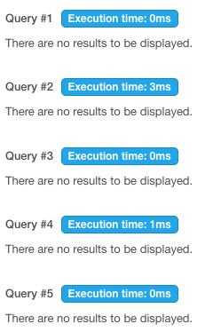

5. Develop queries to retrieve event information,generate attendee lists, and calculate

-- Retrieve Event Information:

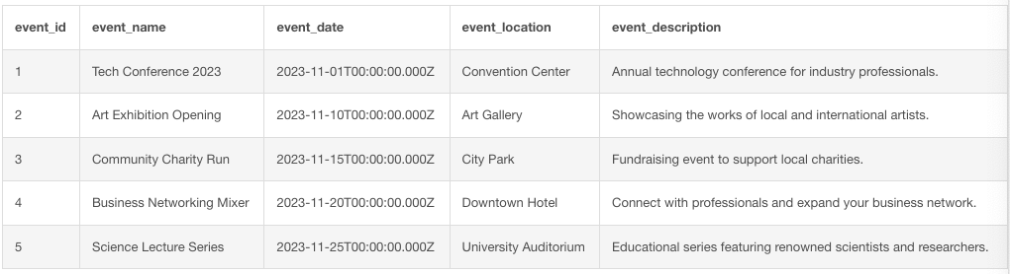

-- Generate Attendee List for an Event:

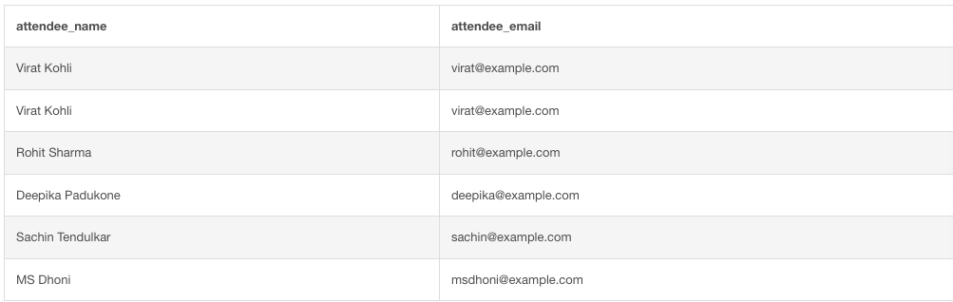

-- Calculate Event Attendance Statistics:

